# Coursera Web development course

### **By Yaakov Chaikin**

### -Sheryl Lindsay’s Notes

Webpage restaurant: <https://www.davidchuschinabistro.com/#/>

Course webpage: <https://www.coursera.org/learn/html-css-javascript-for-web-developers>

## Week 1: HTML

**Downloaded:**

Sublime text 3

Browser-sync

What they do?

Sublime text 3 is an IDE for the code we write

Browser-sync connects your file to a server and can display it on the net. You allowed it in your private home network through your firewall. **Remember that.**

**NOTE:**  when using git clone and git push. Every time you start your website you need to make a push to your git which is very hard. So we use browser-sync so we can see modifications that we make immediately by going to the file where our code is starting browser sync.

$browser-sync start –server –directory –files “*”

$ browser-sync start –server –directory –files “**/*”

This is to check our immediate change to code while coding from local device.

To keep updates of html look into:

W3C website

Canido website

W3C validator used to check if your code is still valid.

Make sure your website runs in the browser most used across the globe. Use browser statistics.

**Books recommended for web development:**

|  |  |
| --- | --- |
| **Soft Skills: A Developer's Life Manual** by John Sonmez | **MY ABSOLUTE TOP PICK FOR SOFTWARE DEVELOPMENT CAREER ADVICE.** [Click here to see my review of the book](https://www.facebook.com/notes/coursera-web-dev/this-book-will-help-your-software-development-career/1605484006420395). |

|  |  |
| --- | --- |
| **Web Design with HTML, CSS, JavaScript and jQuery Set** by Jon Duckett | **MY ABSOLUTE TOP PICK.** This is a set that combines 2 books for a cheaper price. *Both books are excellent: very visual, easy to look up things in, and get straight to the point without a lot of blah blah.* |
| **HTML and CSS: Design and Build Websites** by Jon Duckett | **MY TOP PICK FOR HTML/CSS.** Great book that is very visually oriented. It’s very easy to look through, especially if you are in a hurry.*It’s also very concise and to the point.* |
| **Learning Web Design: A Beginner's Guide to HTML, CSS, JavaScript, and Web Graphics** by Jennifer Niederst Robbins | A fairly comprehensive book that talks about the code AND the design aspect of web page development. |
| **Learning Web App Development** by Semmy Purewal | A student found this book and states that "its close to what is taught in this course". Looks like a great book from first glance and does sound close to what we cover in the course. |
| **Mastering Sublime Text** by Dan Peleg | Clear, step by step instructions. *Covers Sublime Text 3!* |
| **Pragmatic Guide to Git** by Travis Swicegood | **MY TOP PICK FOR GIT.** I am a BIG fan of pretty much any Pragmatic programming series book. This one is great as well! *Explains the concepts well, so you are not just memorizing commands.* |
| **Pro Git** by Scott Chacon and Ben Straub | Explains things pretty well. You can **read it for free** online [here](https://git-scm.com/book/en/v2). |
| **JavaScript: The Definitive Guide: Activate Your Web Pages** by David Flanagan | A VERY comprehensive book on Javascript. This Definitive Guide book is a classic. |
| **JavaScript: The Good Parts** by Douglas Crockford | *Another classic!* Written by the inventor of JSON. *Empowers you to harness the true power of Javascript as a language.* |
| **JavaScript and JQuery: Interactive Front-End Web Development** by Jon Duckett | **MY TOP PICK FOR JAVASCRIPT.** Just like his HTML/CSS book, this one is very visual and gets to the point quickly. |

Also try to read first 3 chapter of git.

Always start with <!doctype html>. If not used sometimes styles and such won’t be right.

Flow content and phrasing content.

Block level elements start everything in a new line.

E.g. span can be inside div tags but div cannot be inside div tags.

H1 is the main heading tag and is very important and is a semantic tag.

In example code given: lecture 6 ->sematic-elements.html are all sematic and block level elements like div.

**Characters that should be used instead:**

**>:** &gt;

**<:** &lt;

**&:** &amp;

**©:** &copy;

Want all words to always stay on same line irrespective of how the window size is changed: &nbsp;

**“**: &quot; (some encodings make this error)

Under <a>

Which uses “href”, if we use target=”_blank” the new webpage accessed always opens in a new tab.

To go to different sections of the page using href, see example-> lecture 09->link-same-page.html

To **add comment line** in html <!--type anything -->

When **adding images** always specify **width** **and height.** This is because without it, when the net is slow sometimes the image takes a long time to load and will keep changing indent and if the photo url is broken, it shows it in a unappealing weird way.

**To make internet slower and try to reload the page slowly:**

in chrome more->tools->developer tools or ctrl+Shift+i

and then go to networks and change throttling to lowest or online -> low 3G etc.

Week 1 over. Example code for the week are from lecture 01-10.

## Week 2: CSS

**CSS Zen garden** has around 200 submission for css for that same website. Could be helpful. Look into it.

A file with many CSS rules is a stylesheet. Remember, we change the css for a file by using html tag name. eg p{ color:blue }

Css can be:

1. Inline. Inside a tag use style.
2. In <style> tag within html
3. Or in a external file. Use link tag in thml to the css file. Ef <link rel=”Stylesheet” href=”name_of_stylesheet.css”>

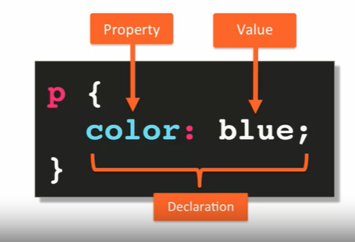



types of selector: (lecture 12 or 11 or 13)



1. Element selector: Chooses an entire tag in all html. Eg. p{ }
2. Class selector. To use this the html document’s tag need to have an attribute ‘class’. Eg. .’clasname’{ }
3. Id selector: html tags hould have id. Eg. #’id name’{ }
4. Grouping selector. Eg. p,.’class name’{ }

Next we learn of combining class selectors**: all types of class selectors can be used in combination**

(lecture 14)

1. In this we use a element selector and style only the specified class under that tag. Eg. p.’class name’ { }. So every <p> tag with this class get the style.
2. Child selector: a element selector which is only a child of another element’tag. Eg. article > p{ }. Here all the p tags that are within a article tag get styled.
3. Descendant selector: eg. article p { }. Even if p is not a direct child, but lies within an article child somewhere, it will get affected.

We can give a tag multiple class name. eg <p class” hello rin”></p>. here hello and rin are two separate classes.

If we style any one of these classes the style will apply. So, it will apply when both these classes are called together. Eg. .hello.rin { }

**Psudo class selector: (lecture 15)**

<shown with example of list and hyperlink <a>>

1. : link -- if it’s a href and link
2. : visited – if that page has been visited
3. : hover – if the cursor hovers above the selector displayed text
4. : active – when someone clicks on the element but hasn’t released it yet.
5. : nth-child(…) – in a list if we only want the 4th <li> then we can say nth-child(4)

Concept in conflict resolution to look into:

1. Origin : Lecture 17 origin.html

Html is processed top to bottom so if a tag overwrites a tag, then if it is in the end of the page it has more precedence.

1. Merge. Merge is merging the different ways to merge css types.
2. Inheritance: Inheritance is that if a body element is given styles and then a paragraph element is given styles, then its inheritance as now even if entire body element has a styles the paragraph elements style overwrites it.
3. Specificity

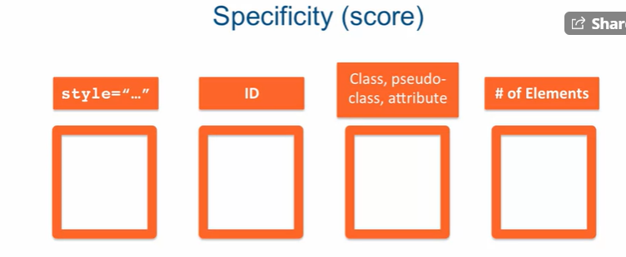

Right to left is more specific and hence will be given more precedence. Based on this scale the specificity score is given with left most given more precedence. Don’t add the score. Just put score in box and take as whole number.eg. also see lecture 17

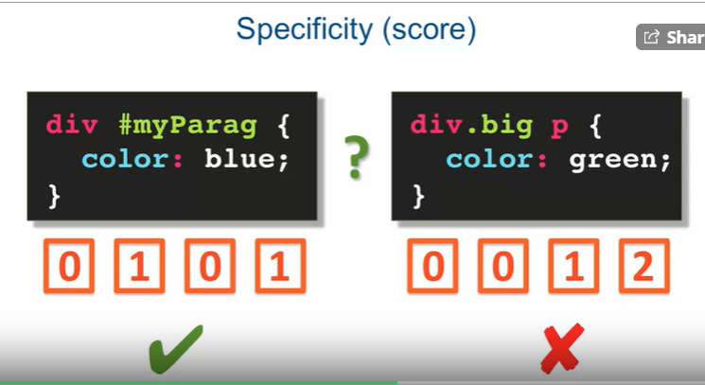

‘!important’ takes highest score but do not use.

Lecture 2=18 has a few diff font types:

* By specifiying 2-3 font types in font-family, we can allow eac comp to use atleast one of them depending on what fonts are downloaded in that computer.
* For color, we can use its name or hexadecimal value for RGB following a ‘#’
* Font-weight can be a value but the default way is to set it to ‘bold’.
* Font-size default is 16px. Pixel is a absolute size. We discuss relative font size later.
* Text-transform lets up uppercase or lowercase it.
* Text-align lets us align the text.

Relative font-size:

Percent: increases the font 12-% or whatever you say times.

Em: this does not over write the size but combines with the previous text size given. So eg: 2em would multiply and make the text size 240%.

Lecture 19 for Box Model:

Padding: distance between box and text. Eg 10px 10px 10px 10px; (top right bottom left.

Border: box size. Eg. 5px solid black;

Margin: box to outside. Eg. 40px;

Width and height can also be changed. (content size). To make it border box set

Box-sizing: border-box; ( not inheretnt)

To make it common across entire html page we use **star selector** which basically applied the style to every element in the html.

Eg *{ box-sizing: border-box}

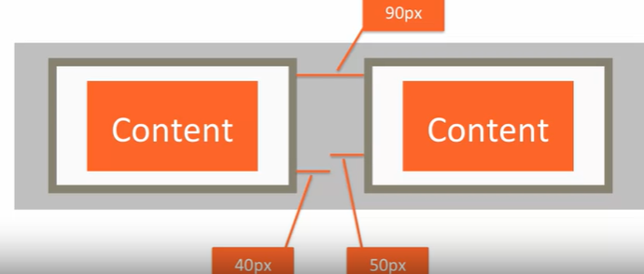

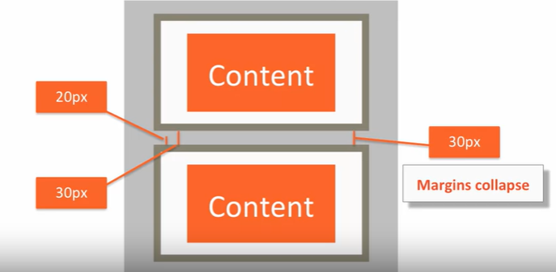

Sometimes even if we mention margin and padding in the body element style, the browser at times gives its own styles to specific tags. In these times always use star selector.

**NOTE:** if we give height and width to our box but we have way too much content that can not fit into the box, then we use **overflow. Overflow: auto;** sets a scrollbar in the box. if we keep overflow: scroll; we add scrollbar both above and below the box.

**Background lecture 20:**

* Background-color
* Background-image: url(“”) <more priority than color>
* Remember that image gets repeated in the width and height of box so we need to include
* Background-repeat: no-repeat;
* Background-position: top bottom; eg. top; top right;
* To overwrite this all in one we say:

Backgroung: url(“”) no-repeat right centre blue;

Position elements by floating lecture 21:

**Float**: what this does is float the box to the specified place.

Eg: float: right;

And this exits from documents standard style view. So it can look mis-aligned.

We can set everything to float left, then all the boxes get placed to the right of the previous box but to make sure there is space we can call something called **clear**  so that not to many elements float on the same line.

**Clear;left; (right or both)** this will clear everything to the elements left and bring it down because nothing should float to the left of the element which has this clear.We use this for a two-column layout and if we make the width:50%, the columns can take half-half of the screen.

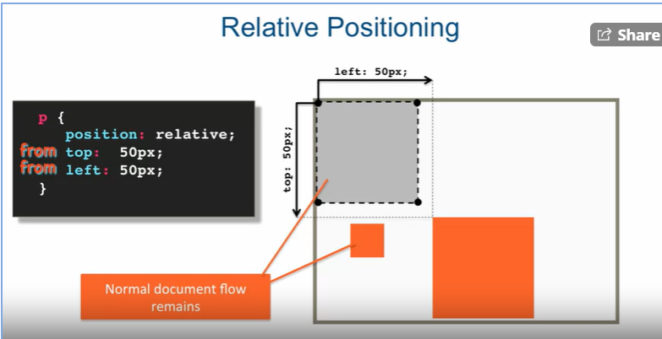

Relative positioning means its relative to its previous position. With absolute it goes off the documents regular flow

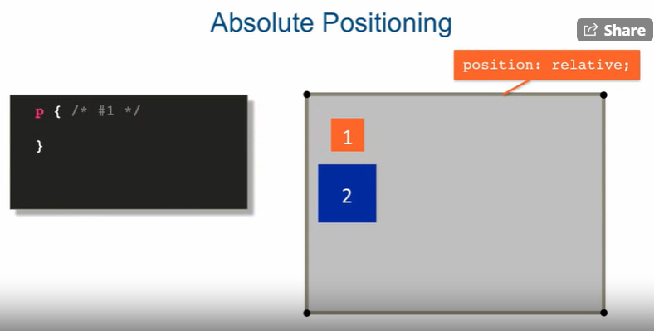

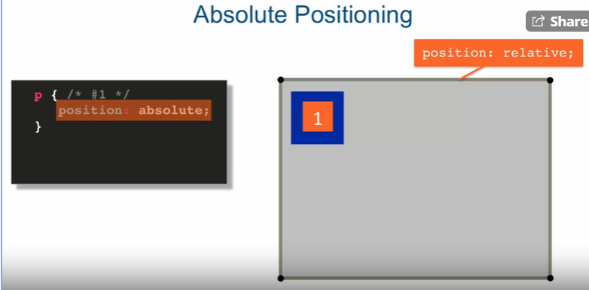

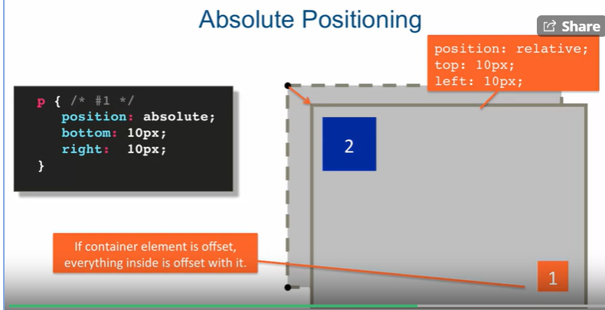

Remember that when setting absolute position and giving the pixel moving points, it takes the points from the last container element that is relative. If nothing is set relative it goes to the corner of the page as html tag is set relative by default. Lecture 22.

Lecture 23: Media Queries for Different user device sizes.

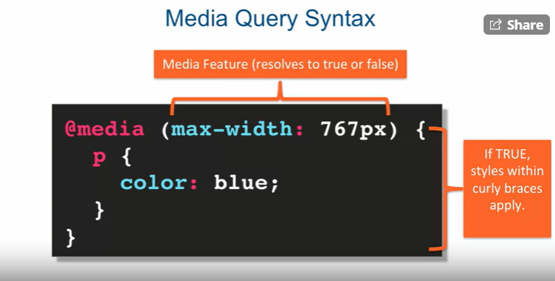

Types of true false questions:

* max-width
* min-width
* orientation
* screen
* print

We can also apply logical operators ‘and’ and ‘,’ for OR.

Usually big devices have min-width:1200px

Medium size devices: 992px and 1199px.

Use chrome developer tools to see what we can do. If we select the phone looking icon we can see how our website looks like in different phones.

Usually to design for different sizes we imagine the page having 12 columns, and based on screen of device place the layouts.

Responsive Design: Lecture 24 (very useful)

Sometimes even if we write a responsive website, the phones have a feature where the do a zoom out so that they can fit unresponsive websites. To tell phones that ours is a responsive website, all we have to do is add a meta tag in the head tag.

<meta name=” viewport” content=” width=device-width, initial-scale=1”>

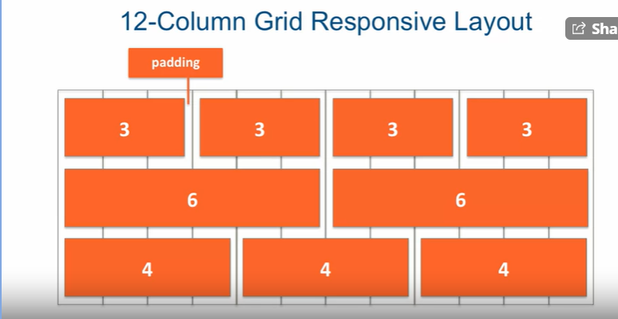

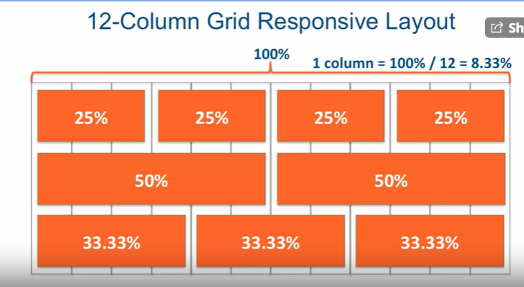

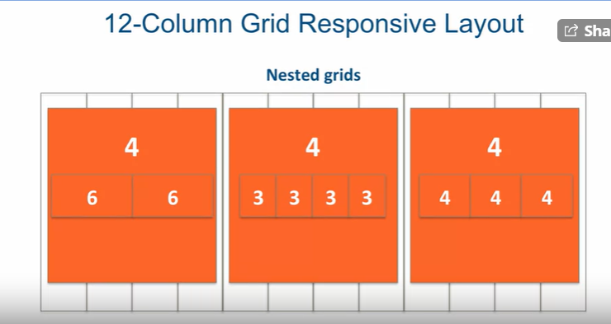

Lecture 25 is basically getting introduced to bootstrap. Here we downloaded bootstrap from the website and then jQuery and added it into the JS folder in bootstrap. When including bootstrap in our html, it applies its own styles which can be very useful.

Grid system is used for bootstrap. Class can be “container or even container-fluid”. Container fluid will stretch the width of the website to fit the screen always and container will give a bit of padding on both sides.

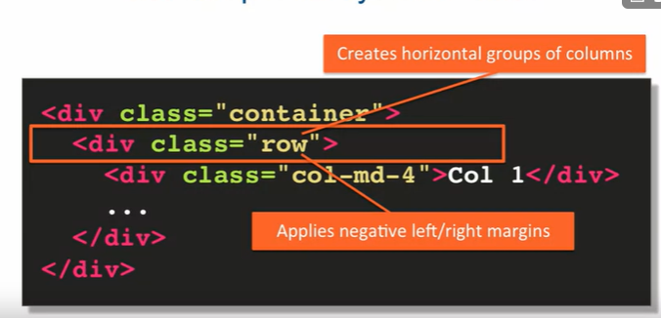

How the grid should look like and basic design principle followed by bootstrap. This is why we use two <div> or any tag as such:

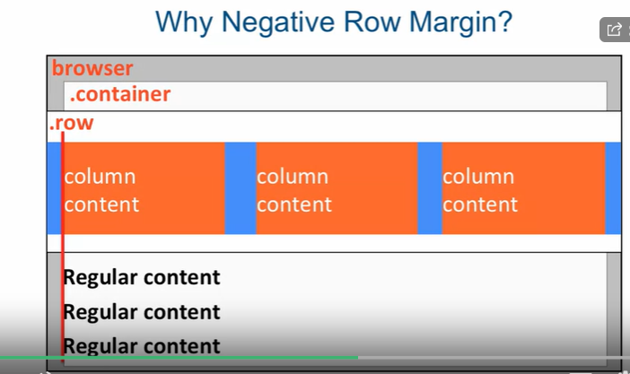

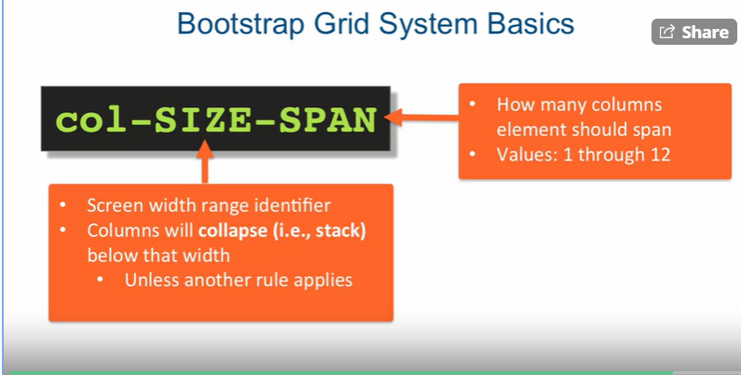

Remember bootstrap is a 12 column grid layout. See lecture 26 example.

Always read through bootstrap main webpage to understand some of the commands.

## Week 3:

Before we start making the website we need to go over a few details

1. if your doing the project for free, always expect something from the customer. i.e the restaurant is ready to make every item in their menu so that a photographer can take the pictures.
2. Limit the number of times they can ask you to make change to the website. After that ask for payment or people will drive you to keep changing so set up that ground rool.
3. Always make mock designs for the website before and show them different websites to choose and see what the customer likes and does not like. This is because most of the time the customer does not know what he is looking for.
4. Always establish central authority to talk and make final decision or it becomes hard to go back and forth between people.

To start the design, use a website called **balsamiq** which is a good place to start the design. **Stick to google fonts.** Ask designer to use photoshop or such to design the website.

To work with google fonts:

-go to google fonts and search for the font you need

-choose all the versions (bold, regular, etc..) of the font that you need and make sure the radar is green so that it doesn’t put extra loading time on screen.

-Copy the url tag and add it to your html in head tag and also specify the font-family as recommended by the website.

Lecture 30:

As we create the header we use **nav** in the header and bootstrap usually defines it as

**<nav id=”header-nav” class=”navbar navbar-default”>**

Two classes because bootstrap usually indicates it as an element within an element. Next we set the container within the nav tag. This is because the container stretches to the edges of the browser **(<div class=”container”>)** but we only want the website length of our page to be coloured. So the container comes inside our nav.

**<div class=”navbar-header”>** can be used for mobile display always use Bootstrap documentation to understand this**. <div class=”navbar-brand”>** We also use this when we are using the brand name for any company website we create. Navbar-brand is also already floated-left.

Here for image they use an id and load an image on the background by setting it to no-repeat and height and width.

In **bootstrap, class=”pull-left” means the elements will be floated left.**

Research on **text-shadow.** **Line-height** is used to reduce the spacing between lines. When we set **text-decoration** to none, we make sure that the link does not look like a link when we hover over it or focus on it. Because if we are using images this will not look good.

Vertical-align: middle makes sure that the text comes and starts in the middle from where image ends.

If we want something to not appear when not in middle sized or large screens we call class **visible-md and visible-lg.**

Lecture 31:

In small screen we want the side menu to appear like an icon. To achieve this, we can go to bootstrap documentation and see how it is done to get out website to look the same. (under navbar)

Some of the class details like “collapse” are Js that is added in.

Lecture 32:

Here in the small screen we create a button that gives a dropdown of menu and other details. To get this we copy the code down from bootstrap.

Now to add what nav things you need in the dropdown we use an id to index from to button to the details in it.

**Class=”nav navbar-nav navbar-right”** tells that this is part of the navbar and navbar-right tells that we want a navigation bar pulled to the right.

**Class=”glyphicon glyphicon-info-sign”** brings vector based shape that we can change color and can use it. Small symbols.

**<br class=”hidden-xs”>** what this does is that when the screen is in xs, it makes sure the sign next to which the word for the sign was given will come down to make the screen look better.

**<a href=**[**tel:823984098903**](tel:823984098903)**>** this is a trigger that makes anyone that taps this number to call the restaurant or go to call on the phone.

To make it clearer we use <br> because when we are in full screen width the writing comes below the icon but in cs screen it should come to the right in the drop-down box.

To access the dropdown box, we use the id=#’id_name’ and then give the id to when we create the full screen menu with icon. This becomes very useful and convenient to use. We make the dropdown take hidden for full screen and middle-sized screen.

Lecture 33:

We use @media, and write media queries so that when for certain screen size the css doesn’t work we can change it for them. Example. When two floats get too big to fit in one line they jump to the next line. So we should either reduce their size or use “clear: both” so that we don’t overlap and ruin the data beneath it. Clear: both means nothing is to float to the right or left on that element.

**1vw = 1% of viewport width //used in font-size**

Lecture 34:

**class=”img-responsive”** comes with bootstrap and it changes width and height of the image depending on the screen or window size.

When adding an image we can use <img> tag but for a page to be responsive to different screen sizes we have to change the image size every time. For this we can just call a class in css and set the background image of that container to fit the screen well.

Lecture 35:

In the first part to create the division for each row like menu, specials and map, we use the “col-md-4” or “col-lg-6”. This to create the division using <div> tag. We then create another div tag within for each square along with its text.

**Placehold.it** is a website where we can resize our image to any size we want to place in our webpage.

Background-position: centre; makes sure our photo is always in the centre so even if the <div> tag closes around it, it always stays to the centre.

To add a map in our website, we go to the location and press the menu of the map in google. Then we select embed or share.

The share link is what we copy and paste in < a href=””> so that when user clicks it we go there. To embed the look of the map, we select embed and this has a <ifame> tag that we can copy and paste in our code inside the box tag. Remember to change the height and width. We make width 100% so that it stretches through the entire box container in it.

We can custom set our width and height and make changes so that it always fits into every possible device.

Lecture 36:

**<footer class=”panel-footer”>** gives the footer area for the page which is part of bootstrap. Remember line-height gives spacing between each line in text.

**Always make you css neat by giving comments on which part of your webpage you are editing.** For media queries again make comments within it for each section of the webpage.

Lecture 37:

**Class=”text-centre”** is used to align the text to the centre.

If we predefine the **width** and **height** and make the margin as **margin:0 auto 15px;** this will align the image to the centre of the box.

If you want to add style from bootstrap, search for that class and then copy paste it into your css.

Lecture 38:

In bootstrap if you use **class:”active”.** This will highlight the content of the tag to show that we are in that active page.

To add the clear property we can actually go to the bootstrap page and get the code to do automatic clear so that floated elements do not wrap around text badly.

Lecture 39:

Working on mobile device. Make some minor fixes.

## Week 3: JavaScript

Lecture 40:

We are going to use Js which can slow down sublime. To make it fast always go into the file in which you’re going to code and open sublime text 3. There are few commands you can run to set this up. Then go to the folder that contains your recent now files and open sublime by typing in cmd :

$cd /…/

$sublime .

In the Windows Chrome developer tools, when we select console we can use this tab for JavaScript. To write Js in this console, we undock it and then we can write Js code in Console.

We can create Js code inside the <script> tag. We can place it in the <head> tag or or even create a separate text file for JavaScript. We specify this page in html as <script src=”js/script.js”></script> and we can place this in or outsid. Js always requires closing tag.

Js always executed as a single file sequentially. So even in the browser it runs as a single thread and hence runs an entire js fully.

**Console.log()** is used in the html code inside <script> tags to call values defined in Js. So if in the external script we say

Var x=”hello world” and then call x using console.log(x) in html, it gets executed.

Lecture 41:

Variable definition should always start with ‘var’. It is dynamic so it understands what type of variable you are declaring. You can change the var value into any type whenever you want.

Ex. var x =” hi”;

Syntax for Function:

Function a () {

….

}

Or

Var a= function () {…}

You can call a function as: a();

Ex of a function:

Function compare (x, y) {

Return x>y;

}

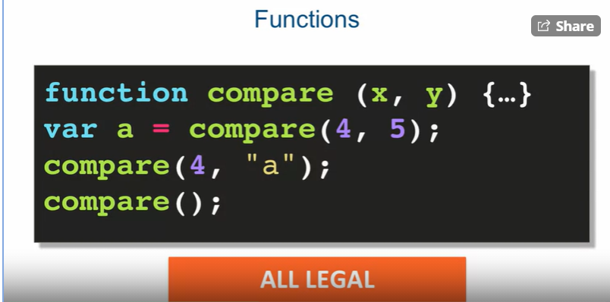

**Scope:**

1. Global: Var and functions defined here are available everywhere
2. Lexical scope (Function): var and functions defined here are only available within that function.

**Scope Chain:**

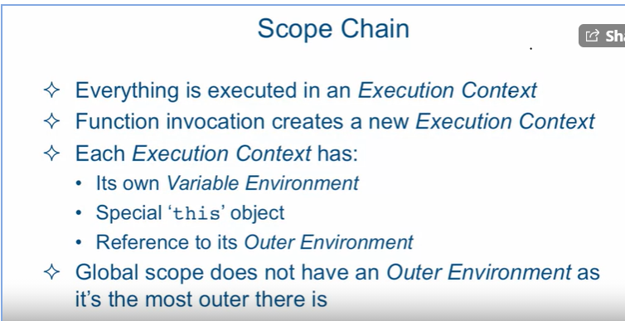

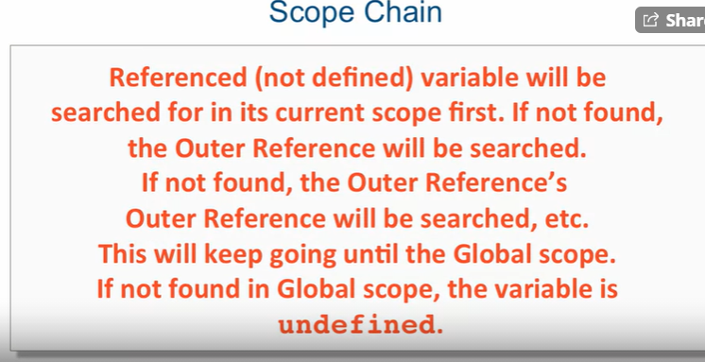

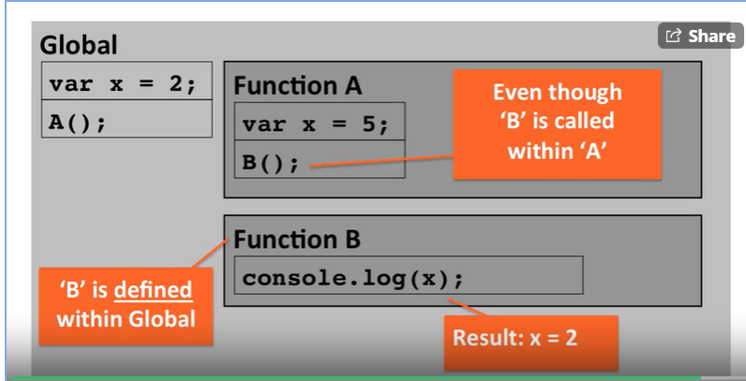

This means that it does not matter if a function is called from within another function. Its outer reference is where the function definition lies not the function call.

When trying to print something on console

**var message = “hi everyone”;**

**console.log (“global: message =” + message);**

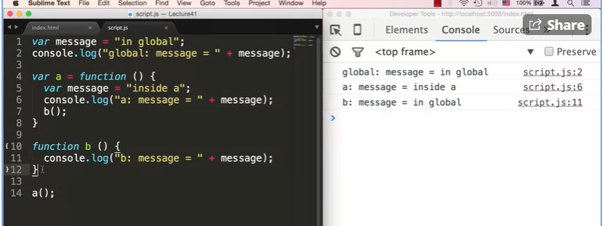

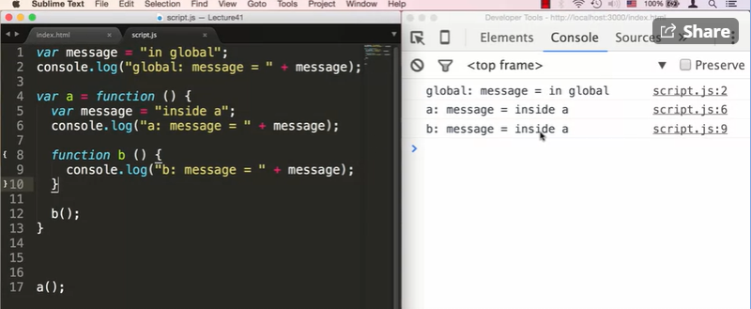

Lecture 42:

Js has 7 built in types: 6 primitive and 1 Object type.

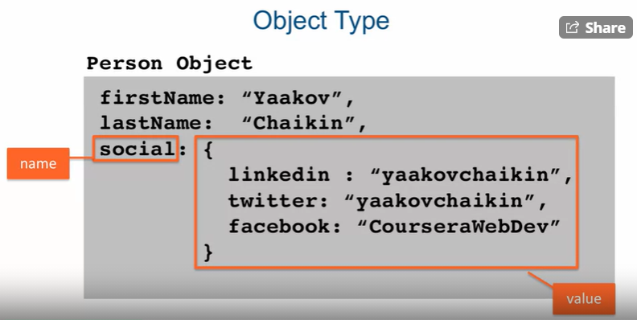

Primitive type represents a single, immutable value. Immutable meaning we can define it only once.

NULL signifies the lack of value but do not set it to undefined. Number is the numeric type in JS and String is for sequence of characters.

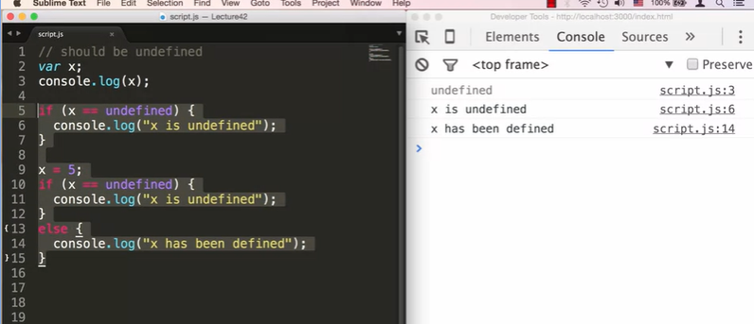

Lecture 43:

Common Language Constructs.

We can **concat** strings by using the + symbol;

**Var string= “hello”;**

**string += ”world”**

**Console.log (String+”!”);**

BODAS gets applied for math operators. **Type coercion:** Js changes a var value so that it can be compared as equal to another var. To make sure Type coercion to not be used we have to use the ‘**===’** sign. This means that the if a string and number are compared, Js does not try to change one data type to the other variables data type. This is called strict Equality.

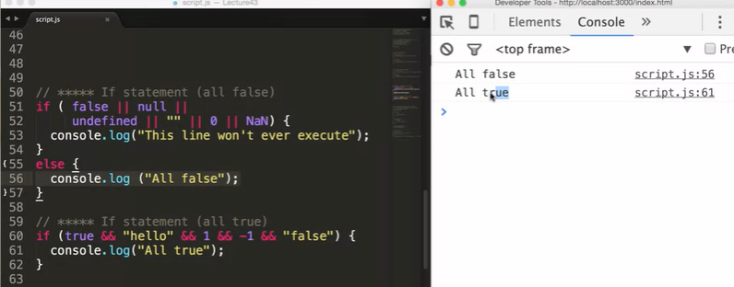

What evaluates as false and true in Js.

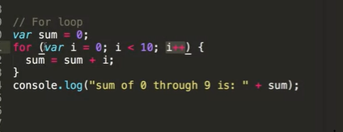 FOR LOOP

Lecture 44:

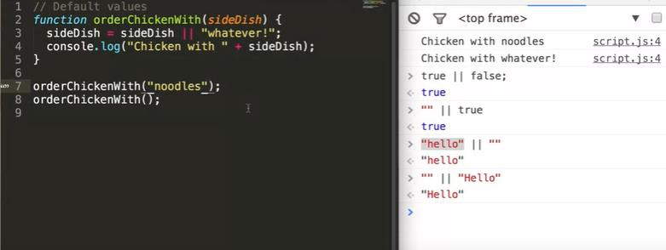

Lecture 45:

Creating new Objects using the syntax **new Objects()** .

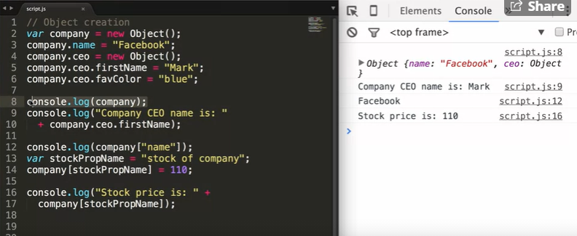

Another way of defining objects:

**Var facebook = {**

**Name: “Facebook”,**

**Ceo: {**

**firstName: “Mark”,**

**Favcolor: “Blue”**

**},**

**“stock of company”: 120,**

**};**

**Console.log (facebook.ceo.firstName);**

Lecture 46:

Functions explained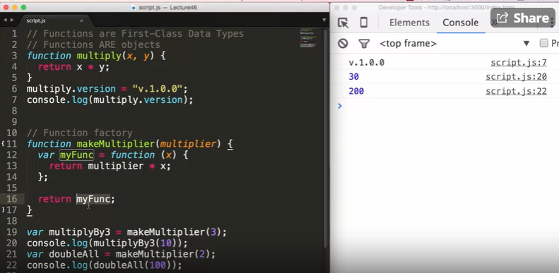

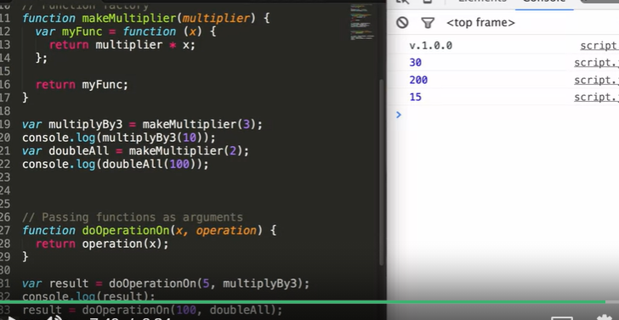

Lecture 47:

Passing variables by values and by reference.

**In Js primitives are passed by value and objects are passed by reference.**

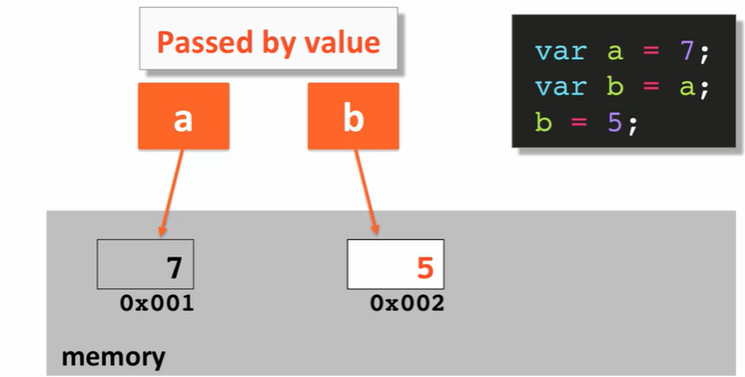

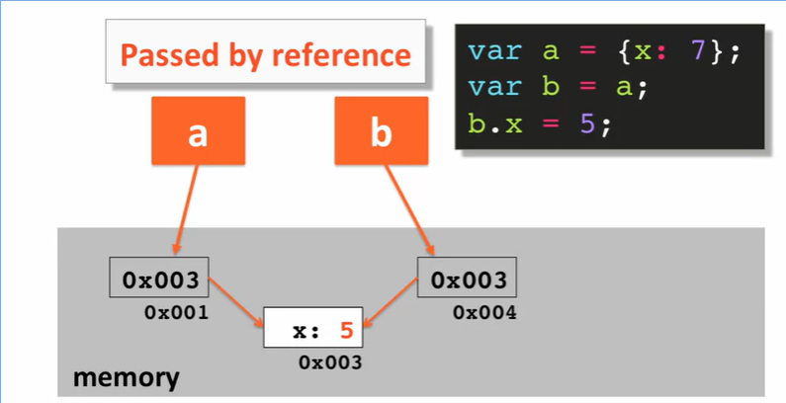

**Now we show an example of passing by reference. Remember that passing by value is for variables and passing by reference is for Objects.**

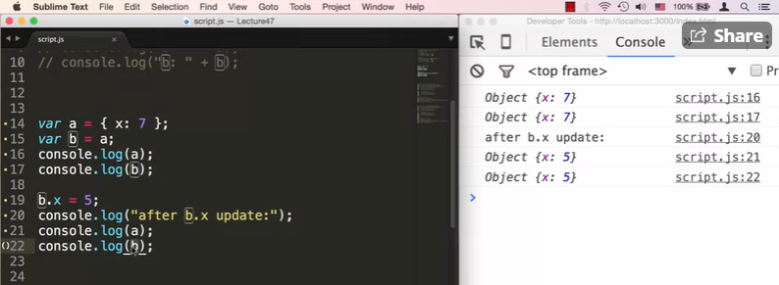

Another example:

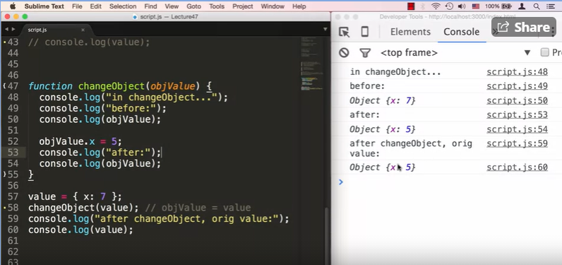

Lecture 48:

Function Constructors, prototypes and ‘this’ Keyword

**‘this’**  points to the global parameter object.

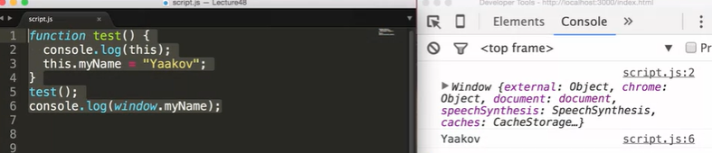

Now we show an example of using **prototype and Math functions along with the ‘new’ keyword.**

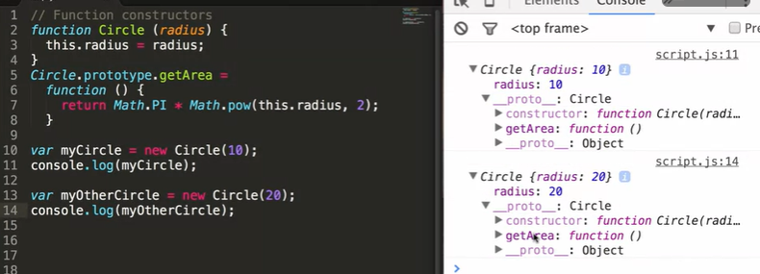

**The ‘new’ keyword is needed when we use ‘this’ in the function as it creates new instances of the function constructor every time to store new values in the Object variables.**

**‘Prototype’ is used because we may create 100s of instances of an function constructor and if each constructor has the same repetitive function, it’s a waste of memory space and processing. So, we define the function for that function constructor outside the constructor definition. If we place the function within the Constructor definition, it takes up the same memory and gets saved in the ‘__proto__’ but it’s a waste of processing.**

If using ‘this’ never forget new keyword. One way is to always start a Constructor name with **uppercase.**  This is to differentiate between function and constructor function.

Lecture 49:

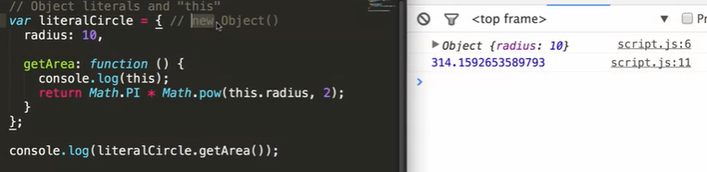

Function within a function:

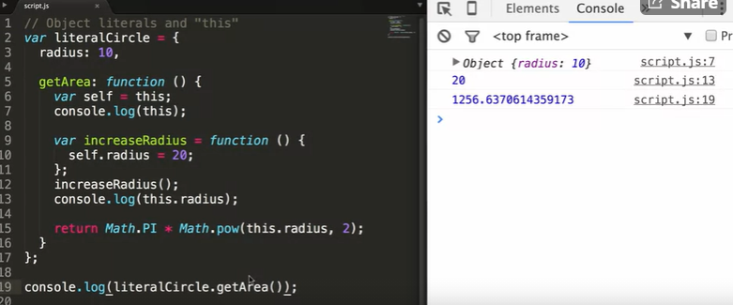

Lecture 50:

Arrays can take defined like an Object. Ex. **Var array= new Array ();**

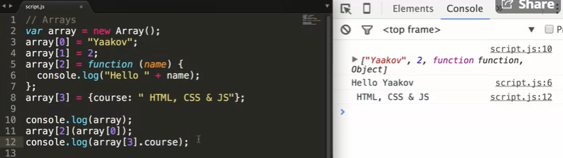

Arrays values can be of different types like in this code snippet. A different way to define an array is shown below:

**Var names = [‘john’, {name: ”lala”}, ”joe”];**

**Console.log(names)**

**//This prints the array. “Names.length” gives the length of the array.**

Issues in Array:

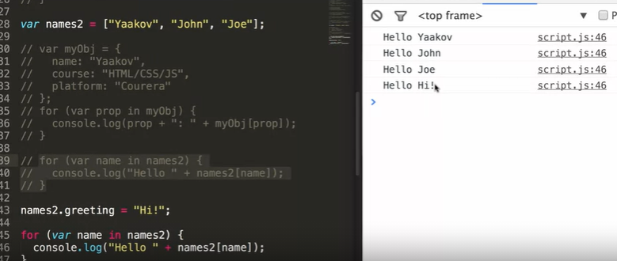

If we notice the commented code and uncommented code, we notice that Array is by itself an Object. When we try to print every element in an Object we can use for loop for each property and print the value. When an array contains String as well as defined as an object, it considers that property and prints the element. So for loop, loops over object data that have nothing to do with core data of that array. Example given above.

Lecture 51:

Closures:

A **closure** is the combination of a function bundled together (enclosed) with references to its surrounding state (the **lexical environment**). In other words, a closure gives you access to an outer function’s scope from an inner function. In JavaScript, closures are created every time a function is created, at function creation time.

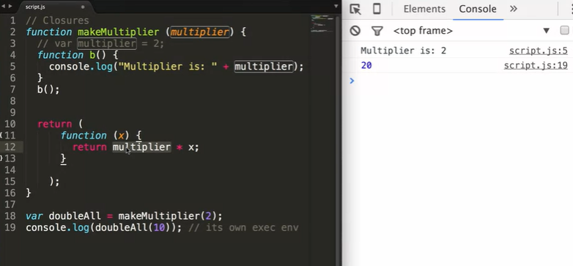

Lecture 52:

Fake namespaces: When we create multiple script files, and change the var value we should remember that the variable value is global and gets carried into all files. To separate the var, we can recreate an function within and object to make sure when we execute, that value in the object property gets printed and not the global scope var.

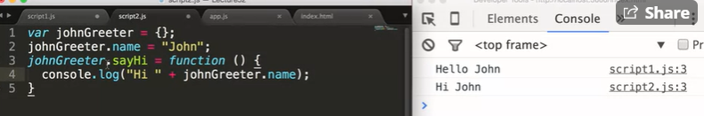

Creating two script files like this instead of using a var called ‘name’ in the global space will work.

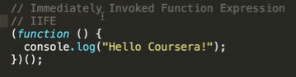

This is an example of an immediately invoked function that executes right after its definition.

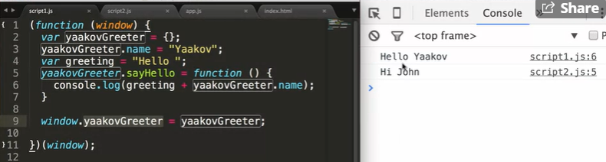

A function called yaakovGreeter.sayHello() can call the function outside.

## Week 5: DOM and Ajax

Lecture 53: DOM

The ‘window’ command on Js has a property known as document that contains the entire html document page. So if we use:

**document.getElementById(“title”)**

**//** It return the tag and all the data within this tag that has this ID.

If we type that:

**Document instanceof HTMLDocument**

**//**this will return true so we know that document is an instance of the existing HTML Document.

We can use HTML Document to see the functionalities it can perform on the webpage.

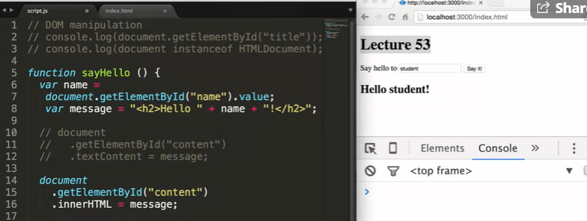

We use the function:

**Document.getElementById(“name”).value** to get the element in the html document with the id as name and we only retrieve the data inside the tag. ‘value’ is used only when the tag in HTML is an input tag.

**Document.getElementById(“content”).textContent = “hello there”** makes the text that we assigned to it appear insdie the tags with the ID ‘content’.

**Document.getElementById(“content”).innerHTML =”<h2>hello there</h2>”** if we use innerHTML instead of textContent, it considers the text as a html tag. So while textXontent might print this text as it is in the webpage, innerHTML only prints ‘hello there’ as a H2.

We now notice everything is inside a function called **sayHello(event).** This is called from the HTML document by including in a **<button onclick =” sayHello ();”>**. This calls the script file and uses that functionality.

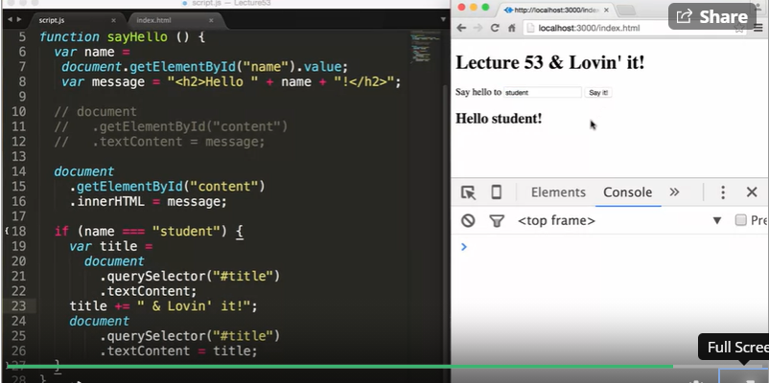

**Var title = “Lecture 54 lovin it”;**

**Document.querySelector(“#title).textContent=title;**

What happens is that querySelector can be used as how we define the tags to use like in css. So as we use the ‘#’ symbol the query selector looks for an ID called title. Id we use “h1” in querySelector it will choose the first h1 tag to make the change that you suggest. To make changes to all the h1 tag you can use the **queryAllSeclector.**

Lecture 54:

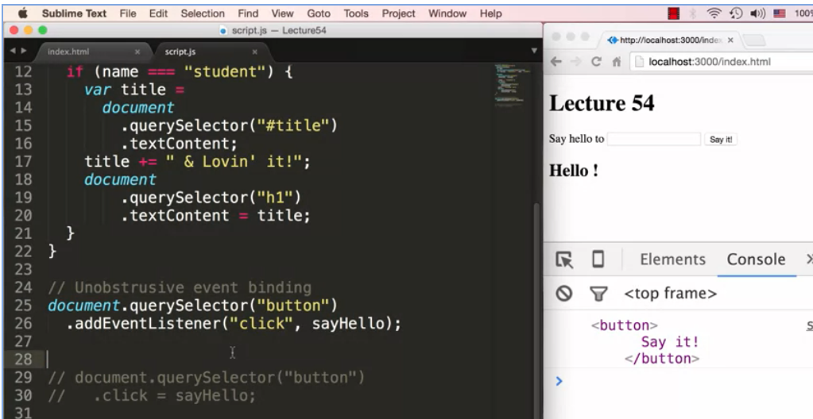

Here we use the **addEventListener(“click”,sayHello”);** on the button element. This can be used so that unlike in the previous lecture, we do not need to use the **onclick=”sayHello();”** in the <button> tag. We can just use the assEventListener function so that when the tag comes an Event such as a click can call the required function. Another advantage is that, since we call that tag, when we use “**this” in the function it will point to that tag.** Look at the console in the above picture.

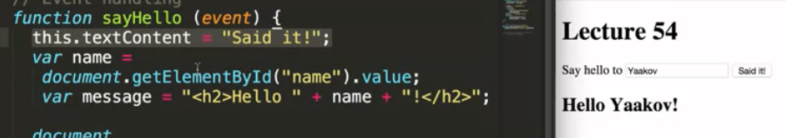

We use eventlsitener also because now its simpler to use this function to change functionalities inside that tag.

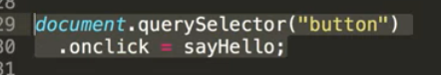

We can also trigger the onclick in Js as so, and call sayHello object.

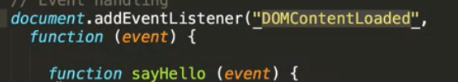

We always had to place the script tag in the end of the HTML page. But if we use the above function and place all out script inside it since they are only functions, then we can place the <script> tag in the start of the HTML page. And the **script will be loaded before the images and videos of the page are loaded.**

Lecture 55:

The ‘Event: argument:

When we print ‘event’ to the console we see that it is a mouse event. There are many types of events like the keyboard event and so on and we can check this out in the event page. 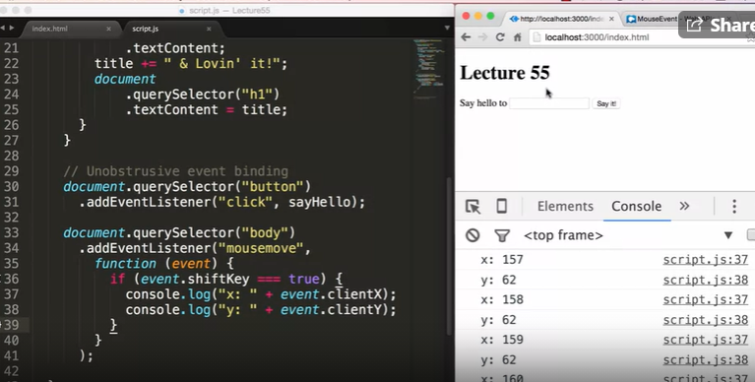

Now we notice that we can choose the type of event. In the example it is a mouseove event. And then we define a function of what is supposed to happen when this move is triggered. The function prints the X and Y coordinates of the user. We also use the shiftkey event. So only if that key is pressed will the x and u coordinates be seen.

Lecture 56:

HTTP BASICS

Ajax is a client and server communication technique. Client and server connect using a language called HTTP.

How HTTP works?

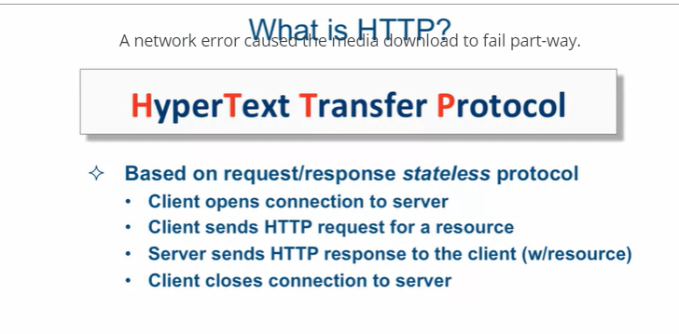

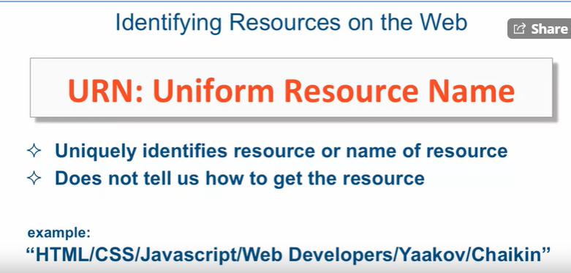

It uniquely identifies everything within a domain.

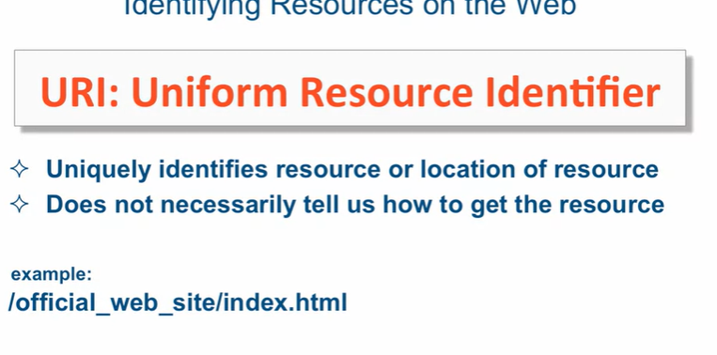

The URI does not take us to the page and hence if we give a URI to someone, they mostly will not understand where to go. But if we go to the domain and make an extension then the URI will wirk.

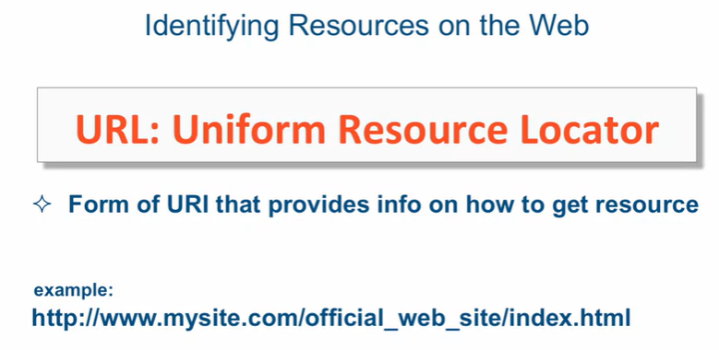

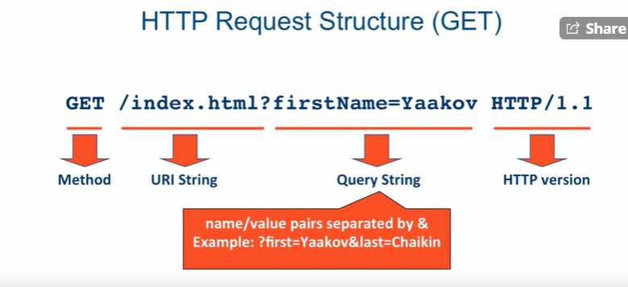

The above example is an URI. Now this request only works if we are already connected to a server. Ex. Coursera.org. if not we would need a URL.

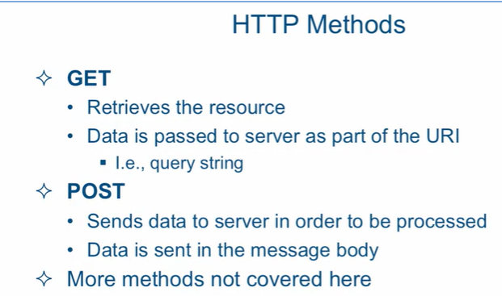

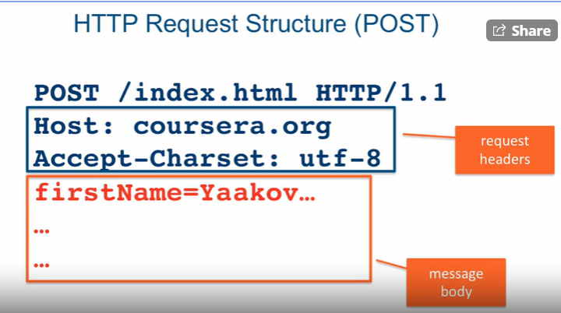

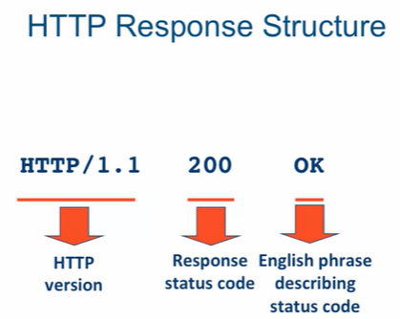

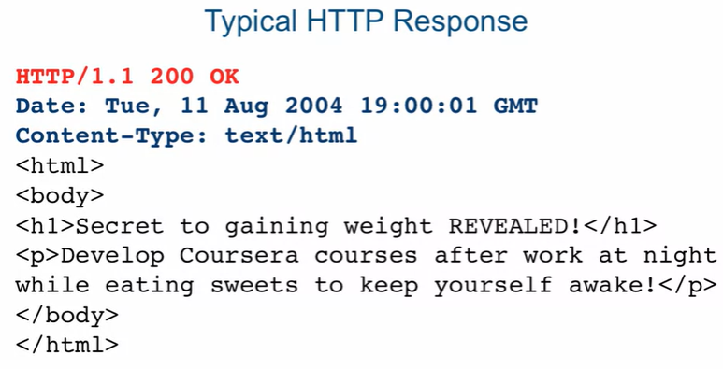

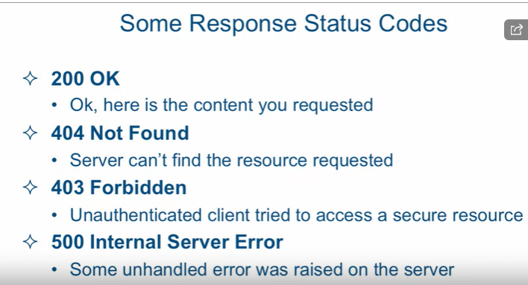

Lecture 57:

Ajax is an Asynchronous JavaScript and XML. Even though Ajax started with XML now plain text and Json format is used to send information back and forth. 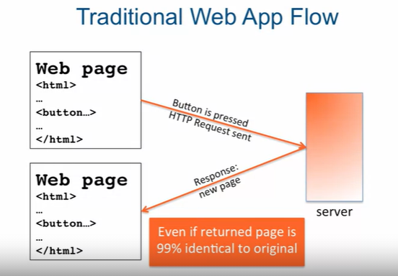

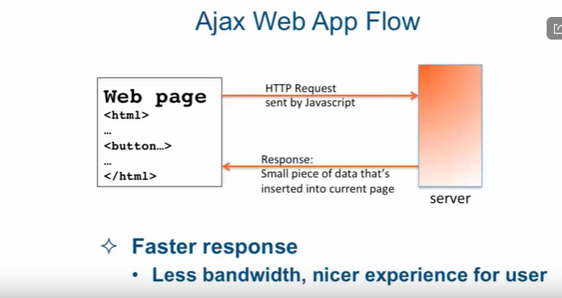

Asynchronous instruction returns right away and it can execute more than one instruction at a time. The actual executions are done in separate threads.

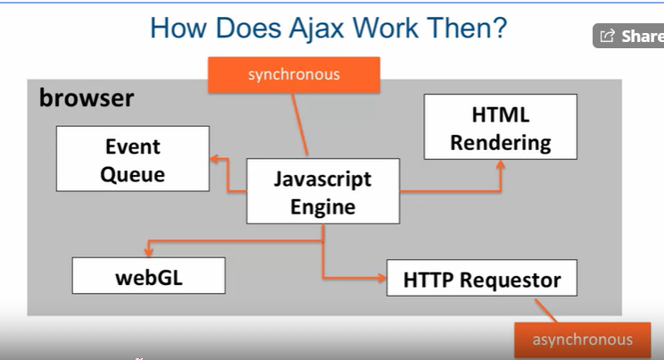

Event queue is sued to queue all the evnts that are defined in the html page.

WebGL is used for graphics that have been defined in the webpage.

HTML rendering is to render and show the entire webpage.

Web requestor is asynchronous and sends request from the server.

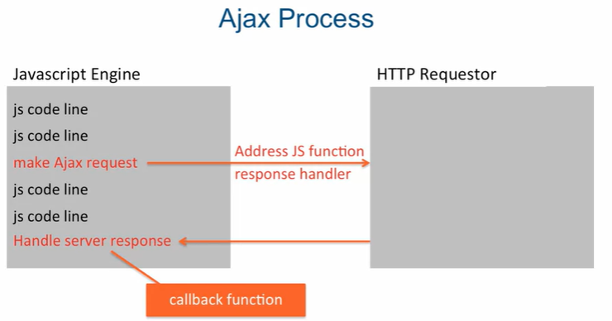Only difference between using Ajax is that it is executed immediately and the page does not have to be reloaded each time. Only necessary details are added inside the current webpage.

**Look at Lecture 57 Code. It contains the entire Ajax code.**

**Always place ajax.js code in front of script.js because script will access the ajax. Look at the code. Check the entire code and go through it to have a proper server connection. That is getting the data from the server.**

Lecture 58:

JSON: JavaScript Object Notation

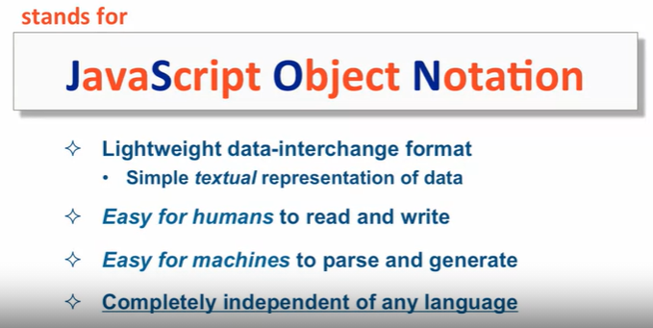

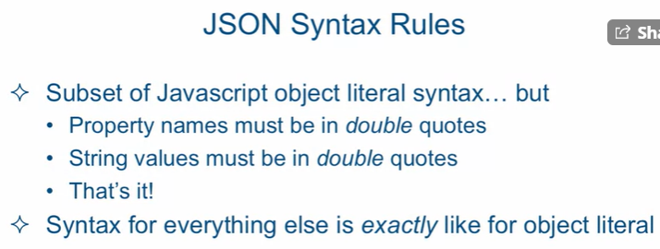

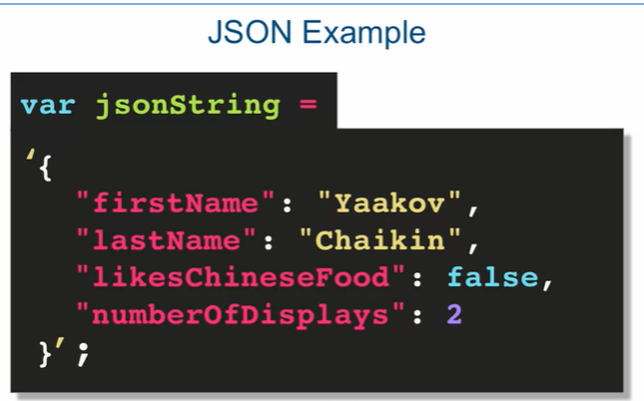

Json is not a javascript object literal. Json is a string.

To convert from JSON to object we use:

**Var obj = JSON.parse(jsonString);**

To convert an object to json string:

**Var str = JSON.stringify(obj);**

**Check the Lecture 58 code in examples. There are some minor changes to the script and Ajax to include JSON and this is very useful so that te JSON format retrieved from the server can be converted to an object in Ajax.js itself before it is used to showcase its change made using Js in the webpage.**

Lecture 59:

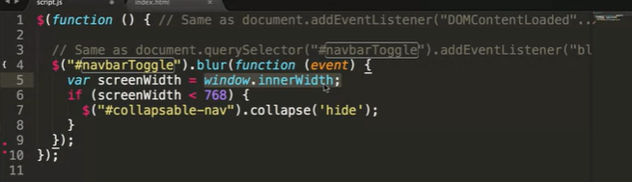

This is the script.js is lecture 59. What this basically does is, in the restaurant website created, the toggle button at pixel 768 appears. When we press it the dropdown menu comes but it stays till we press the toggle button again. To make it disappear we can use JavaScript but we have to use **jQuery. Because the collapse function used for bootstrap only supports jQuery.**

In jQuery, we start with the ‘**$’** as it means the jQuery is executing. When we create a function after the ‘$’ and the open parenthesis it considers it the same as event listener DOMContentLoader. So it gets executed once the page loads but before the pictures load. Now the **“OnBlur”** event is called in jQuery by using the $(“tag id to locate the button or where the event is triggered”). We then use the .blur to trigger the event and then write the function within. If window browser size called by **window.innerWidth** reduces beyond 768 then we collapse the dropdown in that Tag. We call that tag the same way we did when calling button tag. We use the **.collapse(‘hide’)** function to collapse it and we can see this collapse function found in **Bootstrap.js.**

Lecture 60:

We are going t o make the restaurant page a single page application(SPA).

Now to make it more convenient, we place the entire main content in another file. In the Scipt.js file we write the functions to write something into our webpage and at the same time also add some other functions.

One such function is the **pageloader** function which shows a gif icon when a page is loading. To get good loader gif we can go to the **ajaxloader.info** where we can get different types of gifs.

What we do here is the index.html does not have the Main body or content of the page. An Ajax function is called where if index.html header and footer are still loading the pageloader gif plays but once the index.html is loaded and before images are loaded, the Ajax function is called from Script.js and a request with the main page content snippet url are sent. The ajax then retuns the content and it is placed where it is to be placed in index.html.

Lecture 61:

Dynamically loading menu categories View

Here they use a Rails app to get the backend data. So data like the menu catagories and images are saved in the backend and we need to retrieve it in the frontend. We should know that the backend data sends the data in the form of JSON.

Here the backend data is in a different domain from where our website is being hosted. i.e. Github. Now our computer’s browser and Js has the **“same origin same source”** rule. This means that our data has to be in the same domain. This is because if we access a different domain then it has access to enter through our firewall. We do not want the unknown domains to enter through our firewall and hence our browser uses this. We can now use **“cross-origin resource sharing”** to allow access to different particular domain.

To check the HTTP request from backend that has been executed in the page, we can go to chrome developers’ tools and go to network and search for the website uri. With that the data is given in a formatted way.

**LOOK at the Lecture 61 coding.** To get better understanding look at the code snippets.

Here what happens is, three ajax functions are called for the menu categories. First the Json data is taken and then the header of the main content is added and inside that each of the many item is loaded. We use “{{name}}” in the main-content html snippet so that we can replace them with the values in the JSON using Js. We call a for loop and then add a section tag within which all the data in main-content.html is repeatedly placed and loaded to build the webpage.

Lecture 62:

Everything is the same as above but for each type of category we will have a separate menu. Instead of making redundant html pages, we can use function and change the ending of the URL. Example. “URL/ctageory-name?name=NL”. Instead of making new webpages in html, we can change the last two Capital letters in the url to point to the category’s menu items. So now the JSON contains that categories menu itsems and so using the same html we can replace the names in the html page to load our required webpage. **SEE the code for Lecture 62.**

We also add the **class=”clearfix visible-lg-block visible-md-block”**  after every second item in the webpage menu list.

Lecture 63:

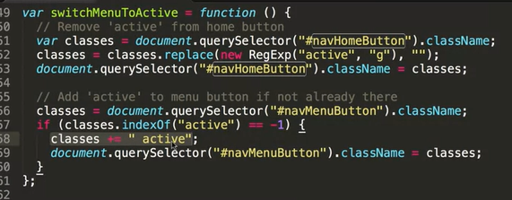

What is happening here is that, we want the menu icon to look active when we are on the menu page and not the home button. So we use #nacHomeButton and call all its class names using “.**className”** and then we change active to empty string and replace it. We then check if the many buttons ID is active and if it is not then we place the active class there so the button gets highlighted.

**COURSE IS OVER**

**Stay tuned at:** [**https://clearlydecoded.com/**](https://clearlydecoded.com/)

**Learnt:**

1. **HTML**
2. **CSS**
3. **JavaScript**
4. **Ajax**
5. **DOM**
6. **jQuery**